VINCENTE K TIBBS CHILD DEVELOPMENT CENTER
183 WILLIAM STREET ENGLEWOOD, NEW JERSEY

201 -568-3937
www.vktcdc.org
ENROLLMENT PACKET
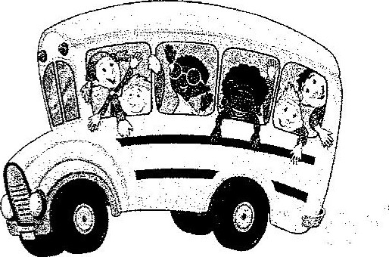
The Vincente K Tibbs Child Development Center is open Monday — Friday 7:30am — 5:30 pm at our air-conditioned facility located at 183 William Street. Summer Camp is be offered to children from the age of 2 1/2 - 13 no partial day attendance.
All Children must be toilet trained
Meals are provided
Breakfast, Lunch and snack.


Activities include arts and crafts, special events, science projects and more.

Vincente K Tibbs Child Development Center
183 William Street
Englewood, New Jersey 07631
201-568-3937
In addition to a completed enrollment packet, we will need the following documents
Your Child's:
- Birth Certificate
- Social Security Card
- Completed Health Form
- Immunization Records
If you are applying for subsidized childcare, you will need to complete and return the Office of Children's application along with the documents requested. A $100.00 registration fee is required to enroll your child in the program as well as $175.00 for one-week deposit, and for the first week tuition of $175.00. These fees are to be paid before your child begins the program.

Our hours of operation are 7:30am — 5:30pm. We provide breakfast, lunch (All cooked on site) and pm snack. Your child MUST be 2 1/2 years old and potty trained to enroll in the center. The parent/guardian will provide.
- Water Bottle
- Extra Change of Clothes
- Toddler Cot Sheet
- Blanket
- Face Mask
Thank you for showing interest in our school. We hope you choose Vincente K Tibbs Child Development Center.

CONTRACT FOR ENROLLMENT
AND
PARENT AGREEMENT

Contract for enrollment for _________________________________________________
Fee schedule: $ ____________________ per week or $ ____________ monthly
PLEASE READ AND SIGN
I hereby agree to comply with the rules and regulations of the Vincente K. Tibbs Development Center regarding fees, attendance, health, parking, clothing, and other items specified in the Handbook for Families issued the each year.
I have received a copy of the Handbook Families which also contains the “Information to Parents Document" in addition to the Centers discipline and dismissal policies.
I understand that may paid weekly or monthly and that no refunds or credits are in event of missed days (illness, vacation, or center closing) I am aware of the scheduled school holidays.
I also agree to notify the Center two weeks in advance of withdrawal, should such an event occur, or pay the difference.
I understand that if payments fall behind more than two weeks, my child will be excluded from the program until the balance is paid or until a payment plan is established with the office.
I hereby grant for my child permission to use all of the play equipment and participate in all activities of the Center.
I hereby grant permission for my child to be included in research evaluations, and pictures connected with the Center.
The Center not be responsible for anything that may happen as a result of false information given at the time of enrollment.
The Center will not assume responsibility for a child Who has not been

properly registered immunized.
____________________________000000000000000000___________________0000000000000000 0 Mother/Guardian Signature Date 0000000000000000000000000000000000000000000000000000000000000000000000000000000000000000000 ____________________________000000000000000000___________________0000000000000000 0 Mother/Guardian Signature Date
____________________________000000000000000000___________________0000000000000000 0 Mother/Guardian Signature Date
Vincente K. Tibbs Development Center
183 William Street
Englewood, New Jersey 07631
Tel. (201)568-3937 Fax. (201)-541-0434
Date of Enrollment________________

NAME OF CHILD___________________________________________________MALE_____FEMALE______

DATE OF BIRTH_________________________________ PLACE OF BIRTH _______________________

NICKNAME__________________________ CHILD’S SOC. SEC. # ______________________________

ADDRESS______________________________________________________________________________

_______________________________________________________ PHONE _______________

NAME OF PARENTS  OR GUARDIANS  EMPLOYERS NAME  & ADDRESS  ENROLLMENT SCHEDULE | PARENT (1) ______________ CELL PHONE_______________  E-MAIL ADDRESS _____________________________  ADDRESS (IF DIFFERENT) _____________________  ________________________ SSN _______________  PARENT (2) ______________ CELL PHONE_______________  E-MAIL ADDRESS _____________________________  ADDRESS (IF DIFFERENT) _____________________  ________________________ SSN _______________  PARENT (1) ______________________ PHONE ____________  _____________________________________________  PARENT (2) ______________________ PHONE ____________  _____________________________________________  3 DAYS _____ 5 DAYS _________  FULL DAY ___________ A.M. ONLY ______  ____________

Child must arrive before 9:00 A.M. and be picked up no later than 5:30 P.M. Registration fee $100 must accompany -this application. Tuition fees and contract are attached and must be signed and returned with application.
PARENT OR GUARDIAN ________________________________ ____________________
Signature Date

APPROVED ________________________________________________ DATE ___________

CLASS ASSIGNMENT _________

The purpose of securing this information is to help the childcare staff better understand you and your child. Your child’s care during is a responsibility we share.
How did hear about the center? ______________________________________________________

Has your child had previous childcare experience? ___________________________________

If yes, where _________________________________________________________________

ESCORT ARRANGMENTS

Names of other persons who may pick up my child from the center:
Name ________________________________________ Relationship __________________________
Name ________________________________________ Relationship __________________________
Name ________________________________________ Relationship __________________________

If there is anyone who may not take your child from the program, please indicate his/her name in writing for the record.
Name ________________________________________ Relationship __________________________
If there is any change in arrangements, I will notify the Center ahead of time. I understand that my child will not be released to anyone who is not authorized in writing by me
Signature ____________________________________________ Date _______________________
In case of an emergency we must have the name of a friend or relative who can be reached to pick up your child when we cannot reach you.
Name__________________________________________ Relationship__________________________
Address __________________________________________ Home Phone _______________________
____________________________________________ Work Phone _____________________

Name_____________________________________________ Relationship__________________________
Address __________________________________________ Home Phone __________________________
___________________________________________ Work Phone _________________________

EMERGENCY MEDICAL TREATMENT AUTHORIZATION

If Vincente K. Tibbs Development Center personnel believe that your child is in need of emergency medical treatment or they will, if time allows, attempt to reach your and then if unsuccessful your family physician.

If you or your physician cannot be reached within a reasonable time, any licensed physician who will render necessary medical service will be called.
Please list below where you can be contacted during school hours and the name and telephone number of your family physician.
Where to call Parent _______________________________________________________

Physician_________________________________ Phone ___________________________

Physician’s address_________________________________________________________

Hospital Affiliation ________________________________________________

I have read and understood the above statement concerning procedures to be followed in the event of emergency medical need for my child. I consent to this procedure and agree that I will be responsible for payment of all medical bills incurred.

__________________________________ ______________
Parent/ Guardian Signature Date
__________________________________ ______________
Parent/ Guardian Signature Date

List Health Insurance Information:

Subscriber’s Name __________________________________________________________
Name of Insurance Carrier __________________________________________________
Identification Number ______________________________________________________
HEALTH HISTORY OF CHILD
Indicate illnesses child has had and at what age:
Chicken Pox ______ Scarlet Fever _________ Mumps ________ Measles ________
Strep Throat _________ Diabetes _________

Does the child have frequent colds? _________ Earaches? __________________
Sore throat? _____________________ Stoma aches? ____________________________

What medication is your child accustomed to taking? ________________________

Does child run high fever? __________________ Range? _________________________
Has your child had any serious accidents? ____________________________________

Explain________________________________________________________________________

9999999________________________________________________________________________

Has your child ever been hospitalized? _________ Reason____________________________

________________________________________________________________________________

Does your child have (if yes, please indicate)?
Food allergies______________________________________________________

Contact allergies ___________________________________________________

Seasonal Allergies __________________________________________________

Medication Allergies ________________________________________________

How does allergy manifest itself?

Asthma ____________ Hay fever __________ Rash _______________ Hives __________

Swelling _________________ Respiratory Problems _____________________________

Itchy, running eyes _________________________ Other _________________________

Has your child ever

Been to the Dentist? ________________ At: what age? __________________

Had vision tested? __________________ At what age? ___________________

Had hearing tested? _________________ At what age? ___________________

Please give a statement below of your evaluation of your child’s overall health.

DEVELOPMENTAL HISTORY

Age at which child: walked alone ____________ Named simple objects ________

Repeated short sentences______________ Sleeps through the night ____________

Toilet trained _______________

Word child uses for urination _______________________________________________

Word child uses for bowel movement ___________________________________________

Does child dress themselves? _________________ Undress self? _____________

Is your child right-handed? ________ left-handed? _____________

What time does your child eat breakfast? ________ Lunch? _____ Dinner? _____

Does your child have any dietary restrictions? _____________________________

What time does your child usually got to bed? ______________ Awaken? _______

Does your child sleep well? _______ Naps? __________ How long? _____________

What activities does child enjoy the most?
Indoors_____________________________________________________________________

Outdoors____________________________________________________________________

Does child have any fears? __________________________________________________

What method of behavior control is being used in the home?

Who usually disciplines? ___________________________________________________________

How would you describe your child’ s personality? _______________________________________

What do you consider to be your child’s assets? _______________________________________

What do you consider potential problem areas for your child? ________

What do you expect your child to gain from their experience in our center? _____________________________________________________________

FAMILY AND SOCIAL HISTORY
Name of Child _________________________________ Date of Birth ______________

Mother or Guardian __________________________________ Age __________________

Race ___________________________ Language Spoken at Home ___________________
Marital Status of Parents: Single__________ Married _______________

Separated ____________ Divorced ________

Remarried __________ Deceased __________

Custody/Visiting Arrangements _________________________________________________________

Note: If either parent has limited or restricted access to your child, a copy of your custody document must be submitted with this application (required by State Child Care Licensing Law).

Siblings of Child:

Name ________________________ Age __________________ In school? ____________

Name ________________________ Age __________________ In school? ____________

Name ________________________ Age __________________ In school? ____________

Stepfamily:
Name ________________________ Age __________________ Relationship? ____________

Name ________________________ Age __________________ Relationship? ____________

Name ________________________ Age __________________ Relationship? ____________

Other members of the Household:

Name ________________________ Age __________________ Relationship? ____________

Name ________________________ Age __________________ Relationship? ____________

PERMISSION TO PARTICIPATE
I grant permission for my child to leave the school premises under the supervision of staff members (at least two) for neighborhood walks. These walks include, but are not limited to, the immediate area bordered by Mackay Park, William Street, and W Linden Avenue.
Teachers and children will not enter any building on these walking trips unless parents have been notified of that specific trip in advance. (I.e.) library, police station, fire house, etc.)
A staff member will remain at the school when children are out to handle phone calls from the parents who may not be aware of spontaneous walks. Part of our program is discovering the world around us through neighboring excursions to observe the changing seasons. Also, we feel children need fresh air and large muscle exercise for their development.
In the event that we are going on a bus trip for a day’s outing, you will be notified ahead of time and asked to sign a specific permission slip for that trip.
Signature __________________________ Date _________________

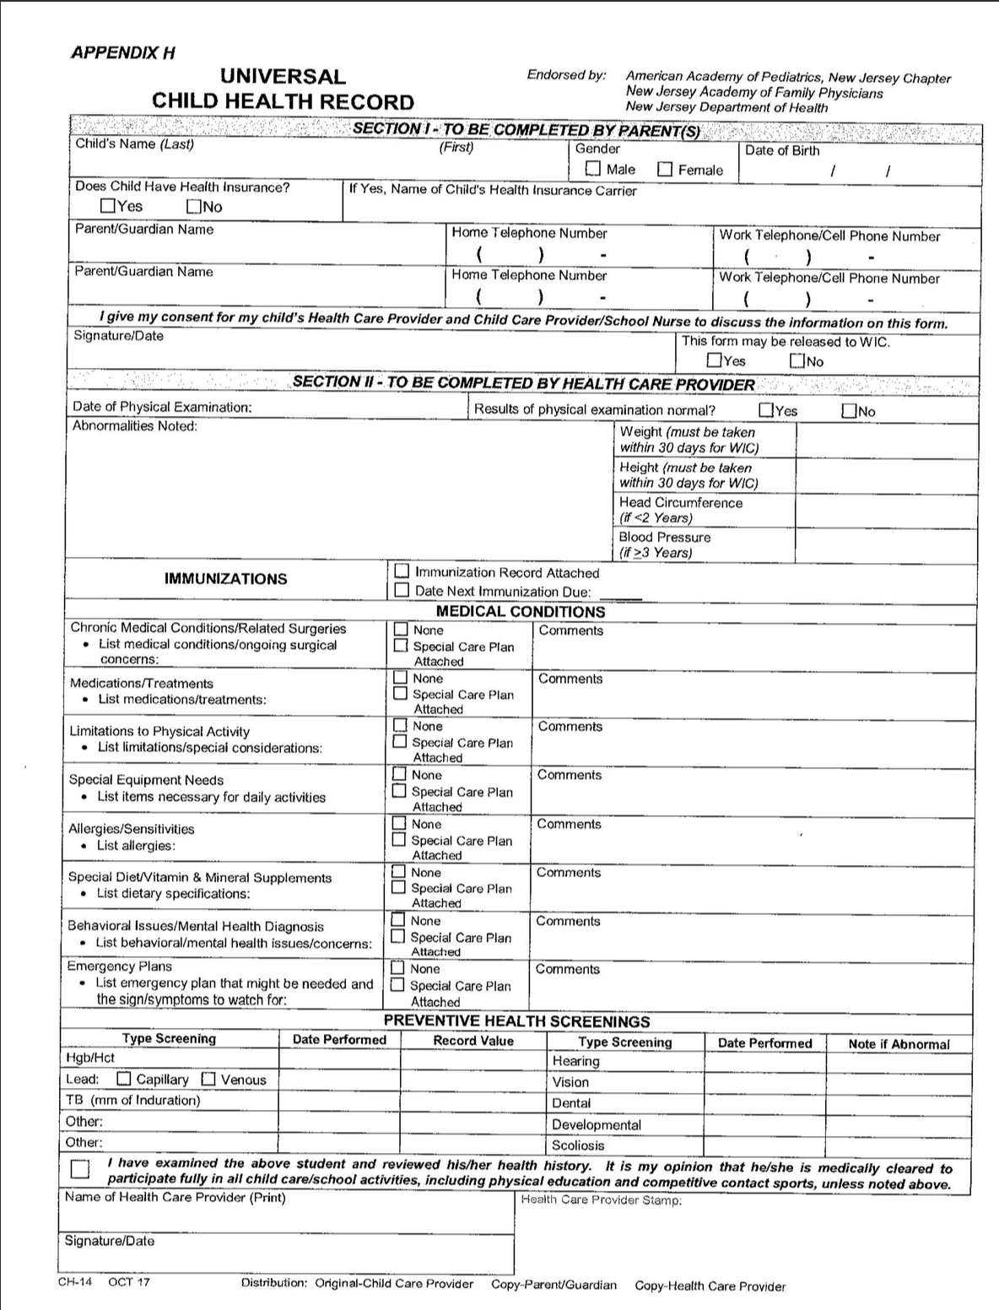
Instructions for Completing the Universal Child Health Record (CH-14)

Section 1 - Parent  Please have the parent/guardian complete the top section and sign the consent for the childcare provider/school nurse to discuss any information on this form with the health care provider.  The WIC box needs to be checked only if this form is being sent to the WIC office. WIC is a supplemental nutrition program for Women, Infants and Children that provides nutritious foods, nutrition counseling, health care referrals and breast-feeding support to income eligible families. For more information about WIC in your area call 1-800-328-3838.  Section 2 - Health Care Provider  - Please enter the date of the physical exam that is being used to complete the form. Note significant abnormalities especially if the child needs treatment for that abnormality (e.g. creams for eczema; asthma medications for wheezing etc.)  - Weight - Please note pounds vs. kilograms. If the form is being used for WIC, the weight must have been taken within the last 30 days.  - Height - Please note inches vs. centimeters. (If the form is being used for WIC; the height must have been taken within the last 30 days.  - Head Circumference - Only enter if the child is less than 2 years.  - Blood Pressure - Only enter if the child is 3 years or older.  - Immunization - A copy of an immunization record may be copied and attached. If you need a blank form on which to enter the immunization dates, you can request a supply of Personal Immunization Record (IMM-9) cards from the New Jersey Department of Health, Vaccine Preventable Diseases Program at 609-826-4860. The Immunization record must be attached for the form to be valid.  "Date next immunization is due" is optional but helps childcare providers to assure that children in their care are up to date with immunizations.  - Medical Conditions - Please list any ongoing medical conditions that might impact the child's health and we are being in the childcare or school setting.  - Note any significant medical conditions or major surgical history. If the child has a complex medical condition, a special care plan should be completed and attached for any of the medical issue blocks that follow. A generic care plan (CH-15) can be downloaded at www.nj.qov/health/forms/ch-15.dot or pdf. Hard copies of the CH-15 can be requested from the Division of Family Health Services at 609-292-5666.  - Medications - List any ongoing medications. Include any medications given at home if they might impact the child's health while in childcare (seizure, cardiac or asthma medications, etc.). Short-term medications such as antibiotics do not need to be listed on this form. Long-term antibiotics such as antibiotics for urinary tract infections or sickle cell prophylaxis should be included.  PRN Medications are medications given only as needed and should have guidelines as to specific factors that should trigger medication administration. Please be specific about what over the counter (OTC) medications you recommend and include information for the parent and childcare provider as to dosage, route, frequency, and possible side effects. Many childcare providers may require separate permissions slips for prescription and OTC medications. | - Limitations to physical activity - Please be as specific as possible and include dates of limitation as appropriate. Any limitation to field trips should be noted. Note any special considerations such as avoiding sun exposure or exposure to allergens. Potential severe reaction to insect stings should be noted. Special considerations such as back-only sleeping for infants should be noted.  - Special Equipment — Enter if the child wears glasses, orthodontic devices, orthotics, or other special equipment. Children with com plex equipment needs should have a care plan.  - Allergies/Sensitivities- Children with life threatening allergies should have a special care plan. Severe allergic reactions to animals or foods (wheezing etc.) should be noted. Pediatric asthma action plans can be obtained from The Pediatric Asthma Coalition of New Jersey at www.pacnj.org or by phone at 908-687-9340.  - Special Diets - Any special diet and/or supplements that are medically indicated should be included. Exclusive breastfeeding should be noted.  - Behavioral/Mental Health issues — Please note any significant behavioral problems or mental health diagnoses such as autism, breath holding, or ADHD.  - Emergency Plans - May require a special care plan if interventions are complex. Be specific about signs and symptoms to watch for. Use simple language and avoid the use of complex medical terms.  - Screening - This section is required for school, WIC, Head Start, childcare settings, and some other programs. This section can provide valuable data for public heath personnel to track children's health. Please enter the date that the test was performed- Note if the test was abnormal or place an "N" if it was normal.  - For lead screening state if the blood sample was capillary or venous and the value of the test performed.  - For PPD enter millimeters of induration, and the date listed should be the date read. if a chest x-ray was done, record results.  - Scoliosis screenings are done biennially in the public schools beginning at age 10.  This form may be used for clearance for sports or physical education. As such, please check the box above the signature line and make any appropriate notations in the Limitation to Physical Activities block.  - Please sign and date the form with the date the form was completed (note the date of the exam, if different)  - Print the health care provider's name  - Stamp with health care site's name, address and phone number

Vincente K. Tibbs Child Development Center
183 William Street, Englewood, N.J. 07631
Tel. (201)568-3937 – Fax. (201)541-0434

Termination Policy
Unfortunately, there are sometimes reasons we need to expel a child from our program either on a short term or permanent basis. We want you to know we will do everything possible to work with the family of the child or children in order to prevent this policy from being enforced. The following are reasons we may have to terminate or suspend a child from this center.
PARENTAL ACTIONS FOR CHILD’S TERMINATION
- Failure to pay/habitual lateness in payments
- Failure to complete required forms, including the child immunization records
- Habitual tardiness when picking up your child
- Physical or verbal abuse to the staff
CHILD’S ACCTIONS FOR TERMINATION
- Failure for a child to adjust after a reasonable amount of time
- Uncontrollable tantrums/ angry outbursts
- Ongoing physical or verbal abuse to staff or other children
- Excessive biting
PROACTIVE ACTIONS THAT WILL BE TAKEN IN ORDER TO PREVENT TERMINATION
- Staff will try to redirect child from negative behavior
- Staff will reassess classroom environment, appropriate of activities, supervision
- Staff will always use positive methods and language while disciplining children
- Staff will praise appropriate behaviors
- Staff will consistently apply consequences for rules
- Child will begin with verbal warnings
- A brief time-out will be given so child can regain control
- Child may lose certain privileges
- Child disrupted behavior will be documented and maintained in confidentiality
- Parent/ guardian will be notified verbally
- Parent/ guardian will be given written copies of the disrupted behaviors that might lead to termination
- The director, classroom staff and parent/ guardian will have a conference to discuss how to promote positive behavior
- The parent will be given literature or other resources regarding methods of improving behavior
- Recommendations of evaluations by professional consultation on premises
- Recommendation of evaluation by local school district child study team

_____________________ _________________________ ______________ __________________
Child’s Name Parent’s Signature Date Staff
Vincente K. Tibbs Child Development Center
183 William Street, Englewood, New Jersey 07631 Tel. (201) 568-3937 - Fax. (201) 541-0434
Emergency Information Sheet
Child’s Name __________________________________________ Date of Birth ___________________
Address _______________________________________________ Home Phone # ____________________
Mother or Guardian ______________________________________________________________________
Mother/Guardian Address _________________________________________________________________
Place of Employment _____________________________________________________________________
Work Phone# _______________________________________ Cell# _______________________________
Father’s Name (if applicable) _________________________________ Home Phone# _____________
Place of Employment _____________________________________________________________________
Work Phone# _______________________________________ Cell# _______________________________
May take your child in to the hospital in the event of an emergency YES___ NO___
Pediatrician’s Name _______________________________________ Phone# ______________________
Address _________________________________________________________________________________
Allergies/Medical Conditions: ___________________________________________________________
Health Insurance Co.___________________________________________ Policy# _________________
My child may be released to the following persons. Child will only be released to individuals listed below.:
Name (First and Last)0000000000000Relationship to Child000000000000000Phone#
_________________________________________________________________________________________
_________________________________________________________________________________________
_________________________________________________________________________________________
Vincente K. Tibbs Child Development Center
183 William Street, Englewood, New Jersey 07631
Tel. (201) 568-3937 -Fax (201) 541-0434
Vincente K. Tibbs Child Development Center is authorized to provide emergency medical care for my child.
Signature of parent or guardian _________________________________________________________
If the parent or guardian cannot be reached in case of emergency, please contact:
Name (First and Last)0000000000000000Address00000000000000000000000000Phone
______________________ ______________________________ _____________________
_______________________________ ____________________
______________________ ______________________________ _____________________
_______________________________ ____________________
______________________ ______________________________ _____________________
_______________________________ ____________________

